Thursday 6th January 2022

Separating Mixtures – Write Up

Starter:

A mixture of iron and sawdust can be separated by **magnetisation.** Sodium chloride dissolved in water (salty water) can be separated by **evaporation.** Mud mixed with water can be separated by **filtration.**

Hypothesis, Variables and Results Table:

Not Applicable (not an investigation)

Equipment

* Filter Paper + Funnel
* 100cm3 beaker
* Evaporating Basin
* Bunsen Burner
* Tripod + Wire Gauze
* Heat-proof Mat

Safety

Safety goggles take care to not get burnt by hot equipment and use the “safety flame” when the Bunsen is not in use.

Diagram

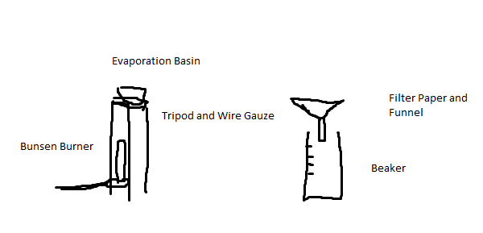

Method

1. Place the Bunsen burner under the tripod and the wire gauze on top, as show in the diagram.
2. Fold the filter paper and insert it into the funnel.
3. Pour the sea water through the filter paper and collect the filtrate in a beaker.
4. Pour the filtrate into an evaporating basin, and heat it using the Bunsen burner so that it boils, until it has almost evaporated
5. When the equipment has cooled down, transfer the evaporating basin to the windowsill and leave to evaporate.

Evaluation

* Systematic Error – Water may be boiled for too long, resulting in less crystallisation of salt.
* Human Error – Filtrate may not have been filtered enough.